Cointegration and ECM: NZDUSD and EURGBP
Method 27 / Engle-Granger on log closes / one-lag ECM / Alpari D1 full available history

Study setup
Logical pair: PX=NZDUSD , PY=EURGBP
Broker symbols: NZDUSD_i , EURGBP_i
Snapshot: 2026-11-03_majors_alpari_D1
Timeframe: D1
Matched window: 1999-01-06 to 2026-11-02 (UTC bar dates)
Matched level count n: 7183
Dropped unfinished last bar dated 2026-11-03 UTC after a tick-volume check against the prior complete day.
ECM lags of deltas: 1
Complete matched rows (Excel): NZDUSD-EURGBP_Coint_D1.xlsx
Complete matched rows (HTML table): NZDUSD-EURGBP_Coint_D1_data.html

Method carried forward
Engle-Granger cointegration works on log price levels, not returns. For each unordered pair, PX is the left leg and PY the right leg. Step one: OLS ln(PY) = alpha + beta * ln(PX) + e. Step two: statsmodels Engle-Granger coint test on (ln(PY), ln(PX)). Error-correction: delta ln(PY)_t = c + kappa * e_{t-1} + lagged delta ln(PY) and delta ln(PX) (one lag each) + u_t. Headline is the Engle-Granger p-value (lower = stronger evidence of a stationary spread) with kappa and beta reported alongside. Same-sample Pearson r of log returns is a side check only. beta is not an automatic lot-size hedge. This is not a trading signal.

Results (headline)
alpha: -0.077491
beta: 0.390425
Engle-Granger t: -1.747686
Engle-Granger p: 0.654767
5% critical value: -3.336981
ECM kappa: -0.000872
kappa t-stat: -1.6420
ECM R^2: 0.001231
spread std: 0.108209
Pearson r (returns): 0.037186

Conclusion
Engle-Granger for PY=EURGBP on PX=NZDUSD: beta=0.3904, alpha=-0.0775, coint_t=-1.7477, p=0.6548 (5% crit=-3.3370). ECM kappa=-0.0009 (t=-1.64). Pearson r of returns = 0.0372. beta is not a lot-size hedge. Not a trading signal.

Charts
Daily closes

Engle-Granger residual spread
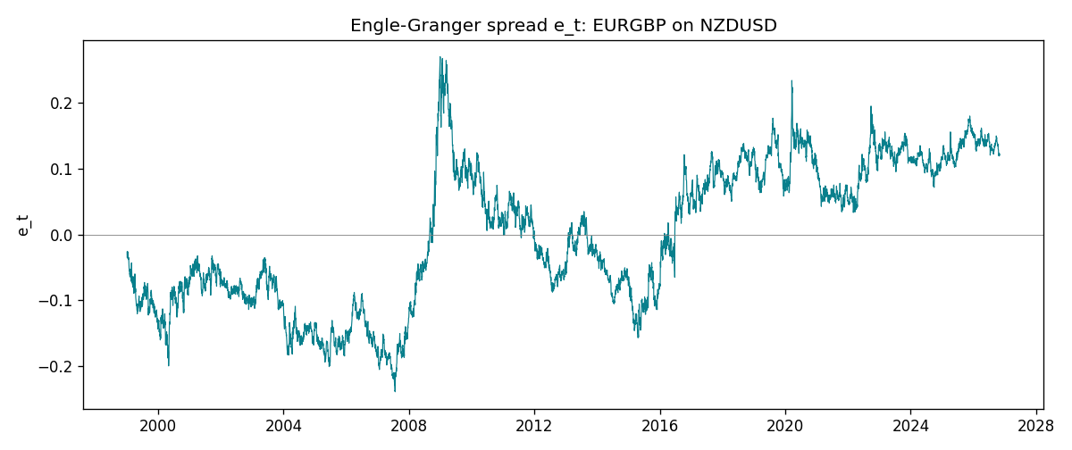
Daily log returns
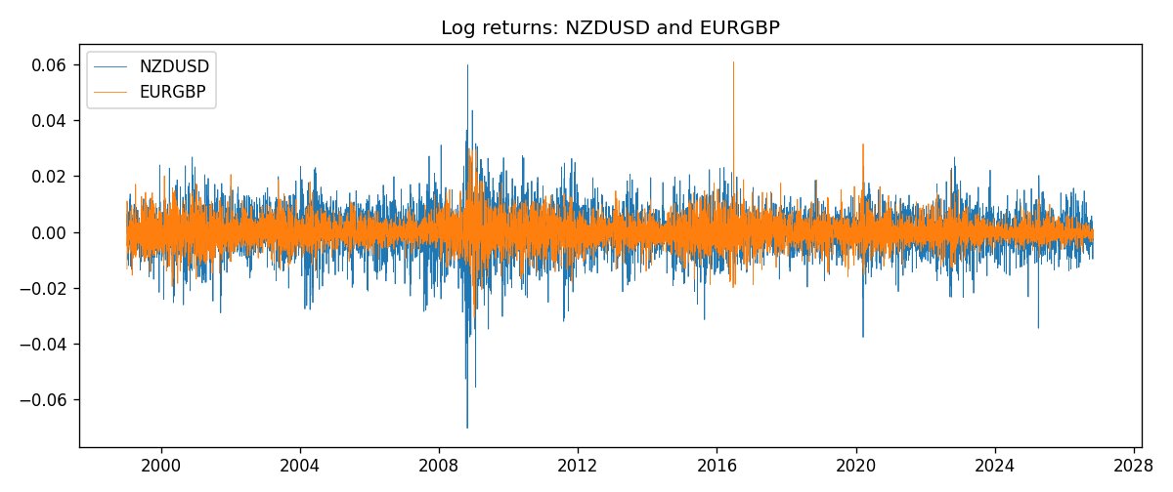

Data report
Matched rows are in the sibling Excel workbook named NZDUSD-EURGBP_Coint_D1.xlsx. Embedding all rows as a Word table is impractical; this file holds column summaries and the first and last 15 matched rows.
Column summaries
column | count | mean | std | min | 25% | 50% | 75% | max
NZDUSD_open | 7183 | 0.65646991 | 0.10818219 | 0.3913 | 0.591455 | 0.6684 | 0.72495 | 0.88218
EURGBP_open | 7183 | 0.78694248 | 0.0966971 | 0.5734 | 0.68755 | 0.83389 | 0.86522 | 0.9769
NZDUSD_high | 7183 | 0.66038812 | 0.10867344 | 0.3961 | 0.5949 | 0.67204 | 0.729365 | 0.88421
EURGBP_high | 7183 | 0.7900202 | 0.09707133 | 0.5789 | 0.6896 | 0.8369 | 0.8681 | 0.9799
NZDUSD_low | 7183 | 0.65278196 | 0.10777661 | 0.3897 | 0.58816 | 0.6642 | 0.720985 | 0.87988
EURGBP_low | 7183 | 0.78424251 | 0.0965143 | 0.5682 | 0.6855 | 0.83166 | 0.86287 | 0.9661
NZDUSD_close | 7183 | 0.65654354 | 0.10817679 | 0.3907 | 0.59181 | 0.6685 | 0.72502 | 0.8822
EURGBP_close | 7183 | 0.78698724 | 0.09669475 | 0.5735 | 0.68775 | 0.83395 | 0.86536 | 0.977
NZDUSD_tick_volume | 7183 | 68736.568 | 123152.54 | 16 | 5594.5 | 33901 | 58513.5 | 1127682
EURGBP_tick_volume | 7183 | 87133.158 | 145499.84 | 154 | 6553 | 44358 | 81413 | 1424684
NZDUSD_spread | 7183 | 30.260755 | 25.633067 | 0 | 9 | 17 | 40 | 80
EURGBP_spread | 7183 | 21.328832 | 19.122264 | 0 | 4 | 13 | 40 | 50
NZDUSD_real_volume | 7183 | 1.6708354e+10 | 8.49951e+10 | 0 | 0 | 0 | 0 | 2.705649e+12
EURGBP_real_volume | 7183 | 2.7872287e+10 | 1.3521454e+11 | 0 | 0 | 0 | 0 | 3.5726265e+12
NZDUSD_log_price | 7183 | -0.43551335 | 0.17588556 | -0.93981528 | -0.52456964 | -0.40271888 | -0.32155604 | -0.12533649
EURGBP_log_price | 7183 | -0.24752643 | 0.12815895 | -0.55599734 | -0.37432988 | -0.18158183 | -0.14460967 | -0.02326863
NZDUSD_log_return | 7183 | 1.073e-05 | 0.0076464 | -0.07027433 | -0.00425909 | 0.00022967 | 0.00458236 | 0.05966839
EURGBP_log_return | 7183 | 2.33e-05 | 0.00487088 | -0.03067367 | -0.00262163 | -9.879e-05 | 0.002558 | 0.06075387
spread_e | 7183 | -0 | 0.10820871 | -0.23909232 | -0.09006927 | 0.00346913 | 0.10034889 | 0.26987078
ecm_fitted | 7182 | 2.516e-05 | 0.00017084 | -0.00115836 | -8.383e-05 | 2.12e-05 | 0.00013088 | 0.0012345
First 15 matched rows (selected columns)
time | NZDUSD_log_price | EURGBP_log_price | spread_e | NZDUSD_log_return | EURGBP_log_return
1999-01-06 | -0.61933925 | -0.35396434 | -0.034667628 | 0.0020455609 | -0.013303338
1999-01-07 | -0.61304294 | -0.34291293 | -0.026074467 | 0.0062963171 | 0.011051402
1999-01-08 | -0.6135969 | -0.3478568 | -0.030802047 | -0.00055396548 | -0.004943862
1999-01-11 | -0.60330648 | -0.34913203 | -0.036094929 | 0.010290425 | -0.0012752393
1999-01-12 | -0.60862223 | -0.345735 | -0.030622495 | -0.0053157489 | 0.0033970309
1999-01-13 | -0.61859645 | -0.34531119 | -0.026304487 | -0.0099742238 | 0.00042381861
1999-01-14 | -0.6187821 | -0.34729054 | -0.028211364 | -0.00018564931 | -0.0019793588
1999-01-15 | -0.61952504 | -0.35496213 | -0.035592883 | -0.00074294208 | -0.0076715819
1999-01-18 | -0.62138481 | -0.35424932 | -0.034153971 | -0.0018597736 | 0.00071280921
1999-01-19 | -0.61952504 | -0.35567544 | -0.0363062 | 0.0018597736 | -0.0014261269
1999-01-20 | -0.61544567 | -0.35367943 | -0.03590288 | 0.0040793678 | 0.0019960086
1999-01-21 | -0.61138288 | -0.35439184 | -0.0382015 | 0.0040627941 | -0.00071240297
1999-01-22 | -0.62343457 | -0.35610368 | -0.035208057 | -0.012051689 | -0.0017118406
1999-01-25 | -0.62698498 | -0.36154392 | -0.03926213 | -0.0035504102 | -0.0054402425
1999-01-26 | -0.61971086 | -0.3621183 | -0.042676511 | 0.0072741158 | -0.00057438255
Last 15 matched rows (selected columns)
time | NZDUSD_log_price | EURGBP_log_price | spread_e | NZDUSD_log_return | EURGBP_log_return
2026-10-13 | -0.57755321 | -0.16891582 | 0.13406656 | 0.0047326165 | 0.00020130374
2026-10-14 | -0.58128385 | -0.16779163 | 0.13664729 | -0.0037306483 | 0.0011241873
2026-10-15 | -0.57652037 | -0.1686672 | 0.13391193 | 0.0047634855 | -0.00087557391
2026-10-16 | -0.57077027 | -0.17070529 | 0.12962886 | 0.0057501001 | -0.0020380844
2026-10-19 | -0.56887856 | -0.1712748 | 0.12832078 | 0.0018917133 | -0.00056950988
2026-10-20 | -0.56515862 | -0.17486542 | 0.1232778 | 0.0037199341 | -0.0035906254
2026-10-21 | -0.56206629 | -0.17627189 | 0.120664 | 0.0030923331 | -0.00140647
2026-10-22 | -0.56536981 | -0.17814629 | 0.12007939 | -0.0033035227 | -0.0018743924
2026-10-23 | -0.56227683 | -0.17732208 | 0.11969602 | 0.0030929853 | 0.00082421033
2026-10-26 | -0.56517622 | -0.17719074 | 0.12095935 | -0.0028993932 | 0.00013133309
2026-10-27 | -0.56544022 | -0.17918648 | 0.11906669 | -0.00026399852 | -0.0019957343
2026-10-28 | -0.57516861 | -0.1785168 | 0.12353457 | -0.0097283914 | 0.00066967224
2026-10-29 | -0.5745467 | -0.17968902 | 0.12211954 | 0.00062190714 | -0.0011722209
2026-10-30 | -0.57435132 | -0.18210958 | 0.1196227 | 0.00019537668 | -0.0024205543
2026-11-02 | -0.57694762 | -0.18121017 | 0.12153577 | -0.0025962955 | 0.00089940465

